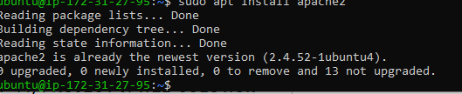

Installation of PHP

Installing virtual host on Apache:

Installing PHP:

